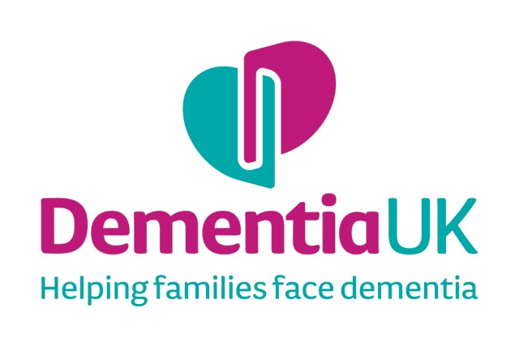

Insert PHOTO

# **MY LIFE STORY**

Name:

I like to be called:

**Introduction to my Life:**

**Date of Birth:**

**Place of Birth**:

**Family:**

Mother’s name and occupation:

______________________________________________

Father’s name and occupation:

______________________________________________

Position in family: (i.e. oldest, youngest etc.)

______________________________________________

Names of sisters and brothers: (eldest first)

Grandparents or other family members such as aunts or uncles

**My Childhood**

*What do you remember about your early childhood?*

*What are your memories from school? What were your best lessons? What were you good at? What did you struggle with? Are there any particular memories of home life you like to recall?*

*Write down any significant memories from your childhood.*

**My Working Life**

What did you do as your first job?

Where did you work? (including work in the home)

What was it like? Did you go on to do different jobs?

If you had your time again, would you do the same job or something else?

Write down any significant memories about work.

**Significant relationships**

Who were the significant people in your life i.e. friends/ family?

Did you get married or have a long-term partner?

Memories of your wedding day- the place, the dress, weather etc.

Did you have children? If so, how many and what were their names?

Did you have any favourite pets?

**(Include any photos)**

**Significant Places**

Where would you say has most been ‘home’ to you?

What memories do you have of the place you lived the longest or spent your happiest times? i.e. the buildings, shops, countryside, local people and community?

Are there any other places that were and are particularly important to you e.g. holiday places, places where significant things took place etc.?

**(Include any photos/ pictures/postcards)**

**Social Activities and Interests**

What did you like to do in your spare time? What were your interests?

Include anything that was important i.e. significant places, regular activities/outings, favourite music etc.

**(Include any photos/pictures)**

**Significant Life Events**

Was there any thing or event that had a significant impact on your life e.g. war, travel, loss of a loved one etc.

Later life/retirement

What were the highs and lows of getting older? e.g. grandchildren travel or time to pursue interests?

Write down anything that influenced you in your retirement i.e. events, people, illness etc.

**My Life Now**

**What is important to me now?**

**Food and Drink**

Do you have any particular preferences about mealtimes?

Do you need any support with eating/drinking?

**Things I like:**

**Things I don’t like:**

**My Appearance**

What is important to you about your appearance?

e.g. clothes, hair, nail

Do you need any help with dressing/personal care?

How would you prefer to be supported?

Do you have any preferences for bathing /personal care e.g baths/showers, soap, perfume/aftershave etc.?

Do you have any particular habits/ routines that you would like people to know about?

**Interests and Hobbies**

**Music**

What types of music do you like to listen to?

Include some favourite songs/ pieces of music

**Television/Radio**

Do you have any favourite radio channels or television programmes?

**Other Hobbies and Interests**

Do you have any other particular interests or hobbies e.g. books/magazines, walking, sport, art etc

**My Likes and Dislikes**

Is there anything that you particularly like or dislike (e.g. food/ dress/ activities/ smells, being touched etc.)

What you do like to talk about? What topics upset you?

What helps you relax? What makes you distressed?

**People who are important to me now**

Who are the important people in your life at the moment?

Please state name and relationship to you

**(Include photos)**

**Wishes for future care**

Do you have any advance plans for your future and end of life care?

Include any specific medical advance directives and/or preferred priorities for care

Who you would like to make decisions for you?

Do you have a Lasting Power of Attorney?

Please include anything else that is important to you that will help others understand how best to care for and communicate with you

**“My Life Story”, The Life Story Book Template is copyright to Dementia UK**

**Registered charity number: 1039404**